Azure Data Engineer: Batch 6

(October 2023)

**Submitted by: Roopmathi Gunna**

# Assignment 8: ADF Data Flow questions

1. Create a pipeline to copy the customer data from csv file to SQL where the customer id is an even number. (Attaching the Customer File)

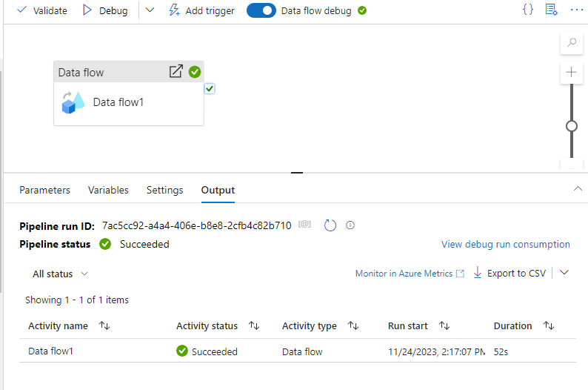

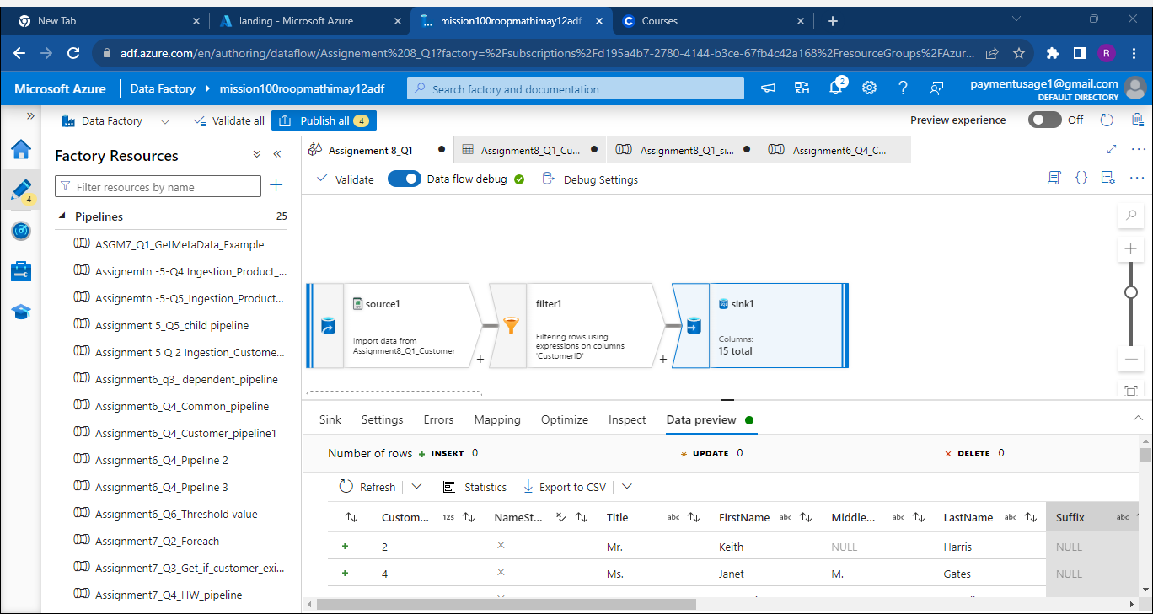

Verified that the Customer_Clone table I created with rows that have even number of CustomerID

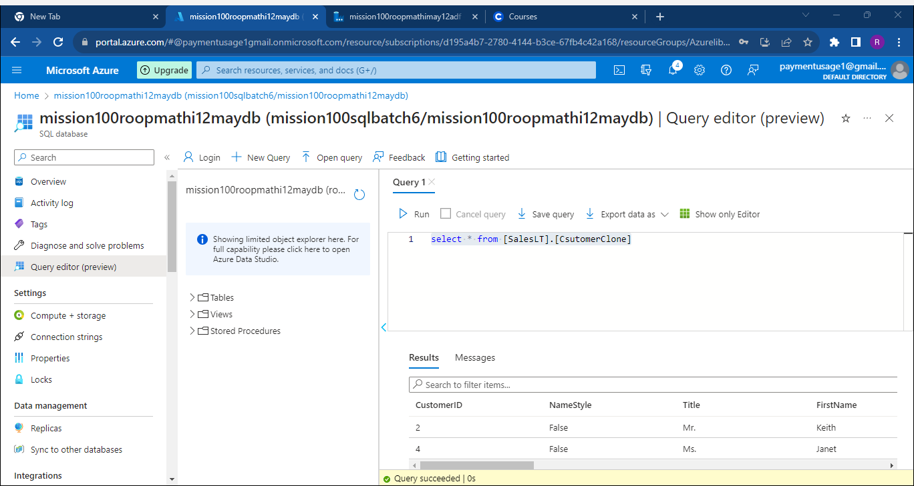

1. Create a pipeline to join the two files (Customer, Customer Address) based on customer id and save the result as a JSON file.

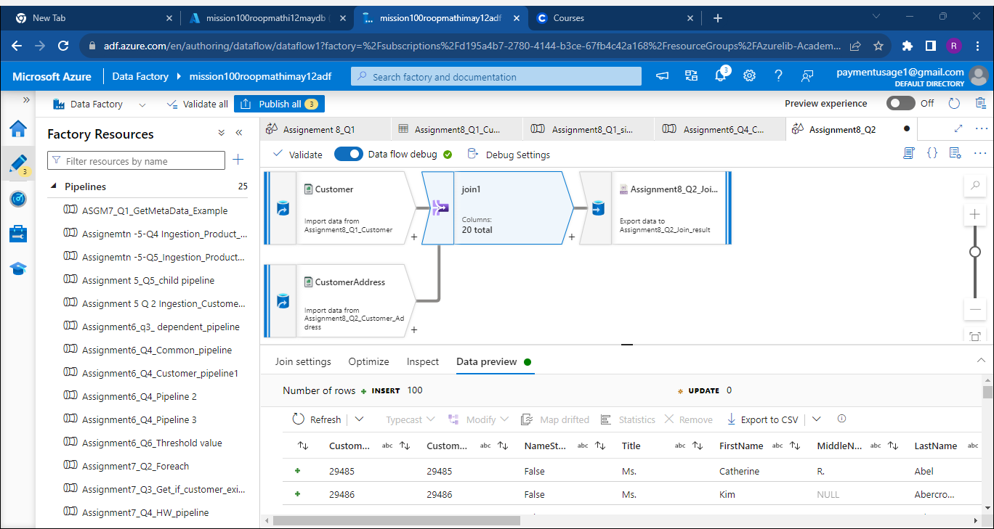

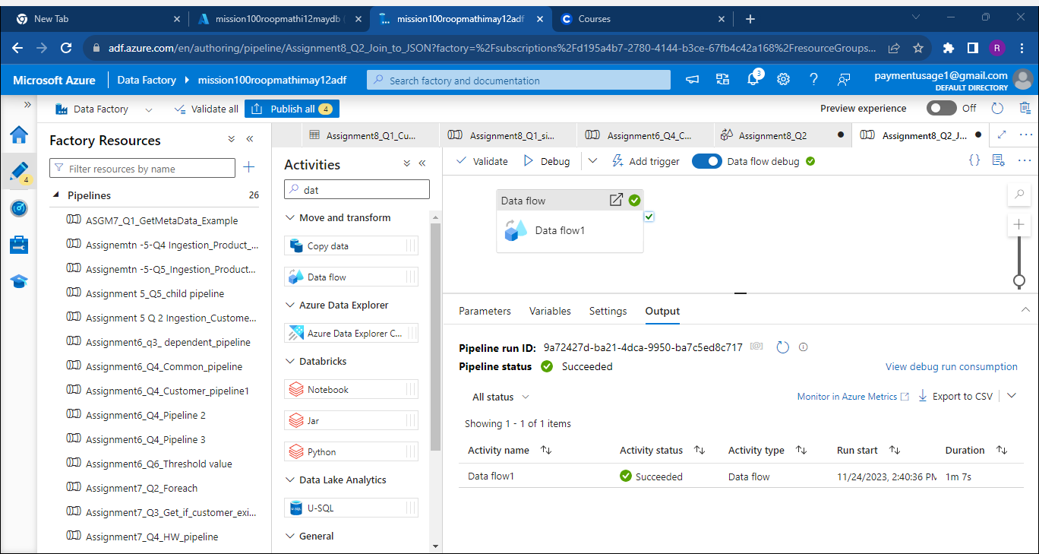

1. Create a pipeline to read the Customer table data from SQL and CustomerAddress data from CSV, join both of them, and then save the result where customer id> 1000 and customer id <2000 in ascending order as a Parquet file.

Here is the dataflow:

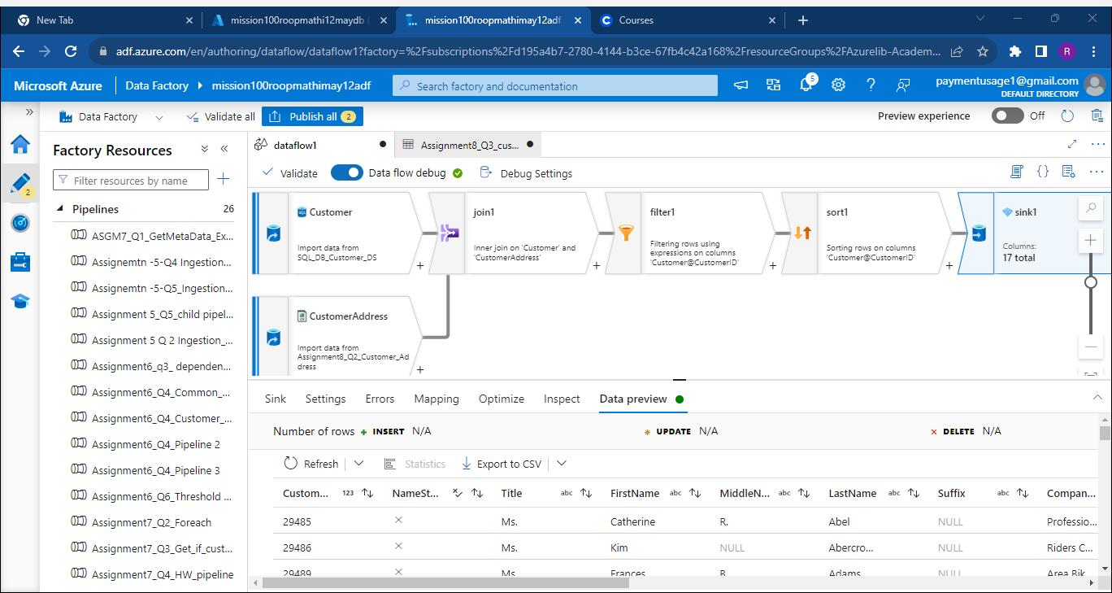

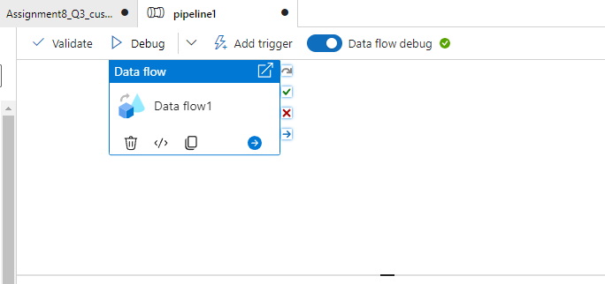

1. create a pipeline to read the Product CSV file, and calculate the highest list Price of any product under each productcategory. Ensure that the product isn't blue in color and save the result as a CSV file inside the ProductResult folder.

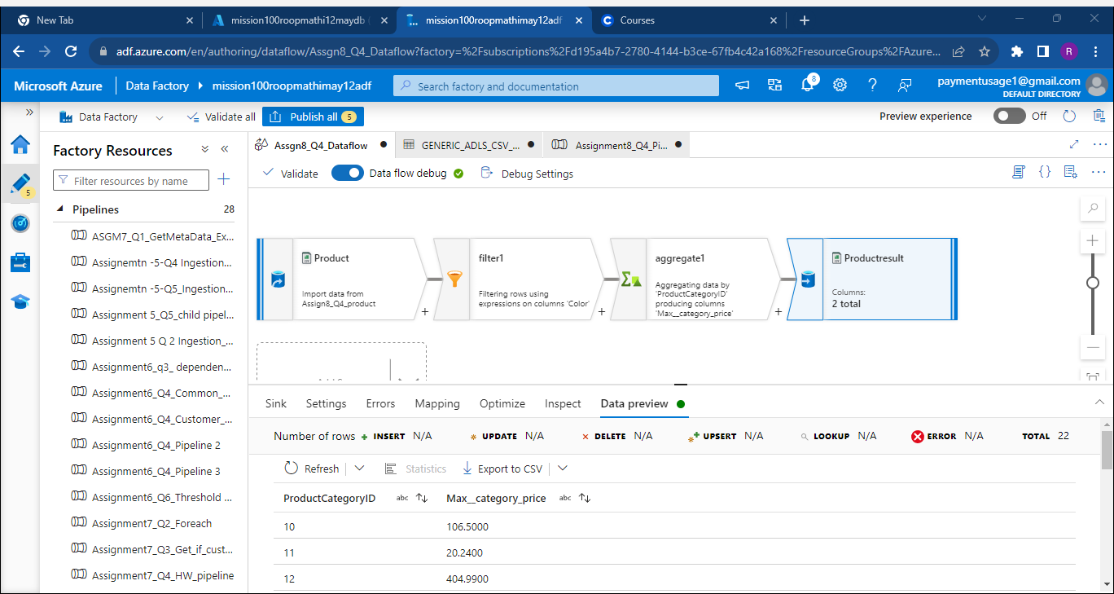

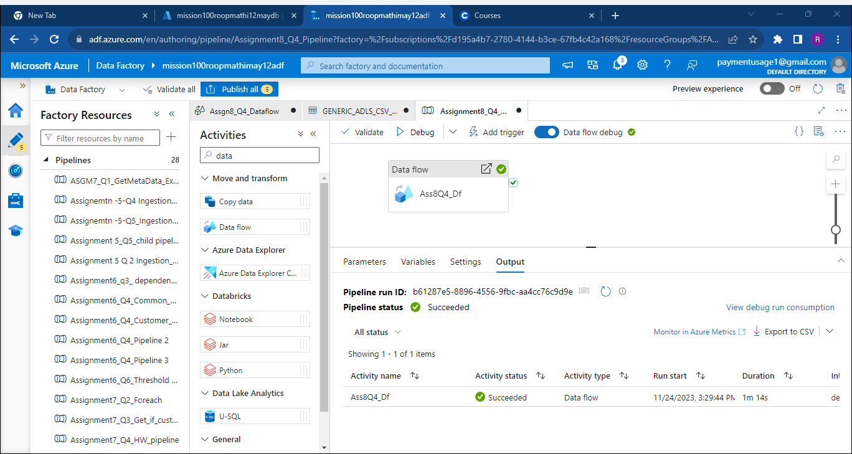

1. create a pipeline to read the Product CSV file, and calculate the highest list Price of any product under each productcategory. Ensure that the product isn't be of blue in color and save the result as a SINGLE CSV file inside ProductSingleResult folder.

Executed the same DataFlow and pipeline as above with Single partitioning in Sink settings